UW-Madison: A Land Grant University

In 1862, President Abraham Lincoln signed the Morrill Act into place. The Morrill Act provided every state with 30,000 acres of land per each member of the Senate and House of Representatives they had in Congress at the time to create new educational institutions. Each state could either sell the land they had received to *create* a new state university or they could use the land given to them to physically expand an already existing state university.[1] The institutions that became the beneficiaries of this support were called Land Grant universities. Land Grant universities were established to extend knowledge in subjects like agriculture, military tactics, and the mechanical arts to the common person.[2] The goal of these universities was to provide the working classes with a “liberal, practical education.”[3] Before these institutions, universities were reserved for students who came from wealthy families and their curriculum primarily focused on classical studies. It was hoped that educating a broader crowd in a mix of practical subjects, as well as the classics, would help support the nation's increasing need for industrialization and an educated workforce. Specific initial curriculum standards of Land Grant institutions, like a requirement to teach military tactics (given the waging Civil War at the time of their creation), prompted certain expectations of the impact these universities would have on the states, and subsequently the nation. Many of the universities that received this support are what we perceive today as state “flagship” schools. The University of Wisconsin-Madison is a Land Grant university and its identity as such has impacted how it works with the state of Wisconsin and the focus of the University’s research.

Founded alongside the 1848 Wisconsin state constitution, the University of Wisconsin-Madison began much like many of its counterparts, teaching mainly classical subjects.[4] However, after the passage of the Morrill Act, UW’s academic scope changed to include the subjects required to be considered a Land Grant university, like agriculture. Somewhat uniquely, the Wisconsin legislature decided to allot the funding they acquired via the Morrill Act to UW-Madison, an already founded university, forgoing the chance to start another university that would focus specifically on agriculture, military training, and the mechanical arts.[5] Many Land Grant universities were founded separately from already established universities at this time to focus solely on “practical” subjects: Texas A&M University being a prime example.[6] UW-Madison has grown to embody the mission of the Land Grant system through their work in disseminating relevant information to the masses. This effort can be seen early on in the University's history through the Babcock butterfat test, which revolutionized the dairy industry and dramatically improved the efficiency of Wisconsin farms.[7] Similarly, since its inception, UW-Extension has provided extensive statewide help to the agricultural sector, connecting the farmers of Wisconsin to the University. This relationship is a direct product of UW-Madison’s role as a Land Grant university.[8] UW-Madison’s early integration of the two realms of higher education, the liberal arts and the sciences, proved extremely important for a later development of the University: the Wisconsin Idea.

The Wisconsin Idea is closely tied to UW-Madison’s status as a Land Grant university and the intended mission of such establishments. Indeed, Wisconsin’s history has long been intertwined with the dairy and farming industries that Land Grant universities were created to support. A secondary goal of the Land Grant system is to prioritize “democratic service and state engagement,” at state schools. [9] The Wisconsin Idea shares this ideal. State engagement is centered in almost every aspect of the University. The Wisconsin Idea centers education as the key to a society that benefits *everyone*, drawing on the reason for the Land Grant system in the first place: to make sure all states had a “state university” to serve their broader populace. Moreover, UW-Madison realized early on that a “practical” education complements a liberal arts education. Educated citizens, in general, improve the wellbeing of the state, yet there needs to be a balance of citizens educated in both the sciences and the liberal arts to maintain a well running society. The Wisconsin Idea expands upon the philosophy of the Land Grant system by not only promoting a workforce that has the capability to bolster the state’s economy, but also by effectuating real changes in the lives of Wisconsinites through research and community involvement.

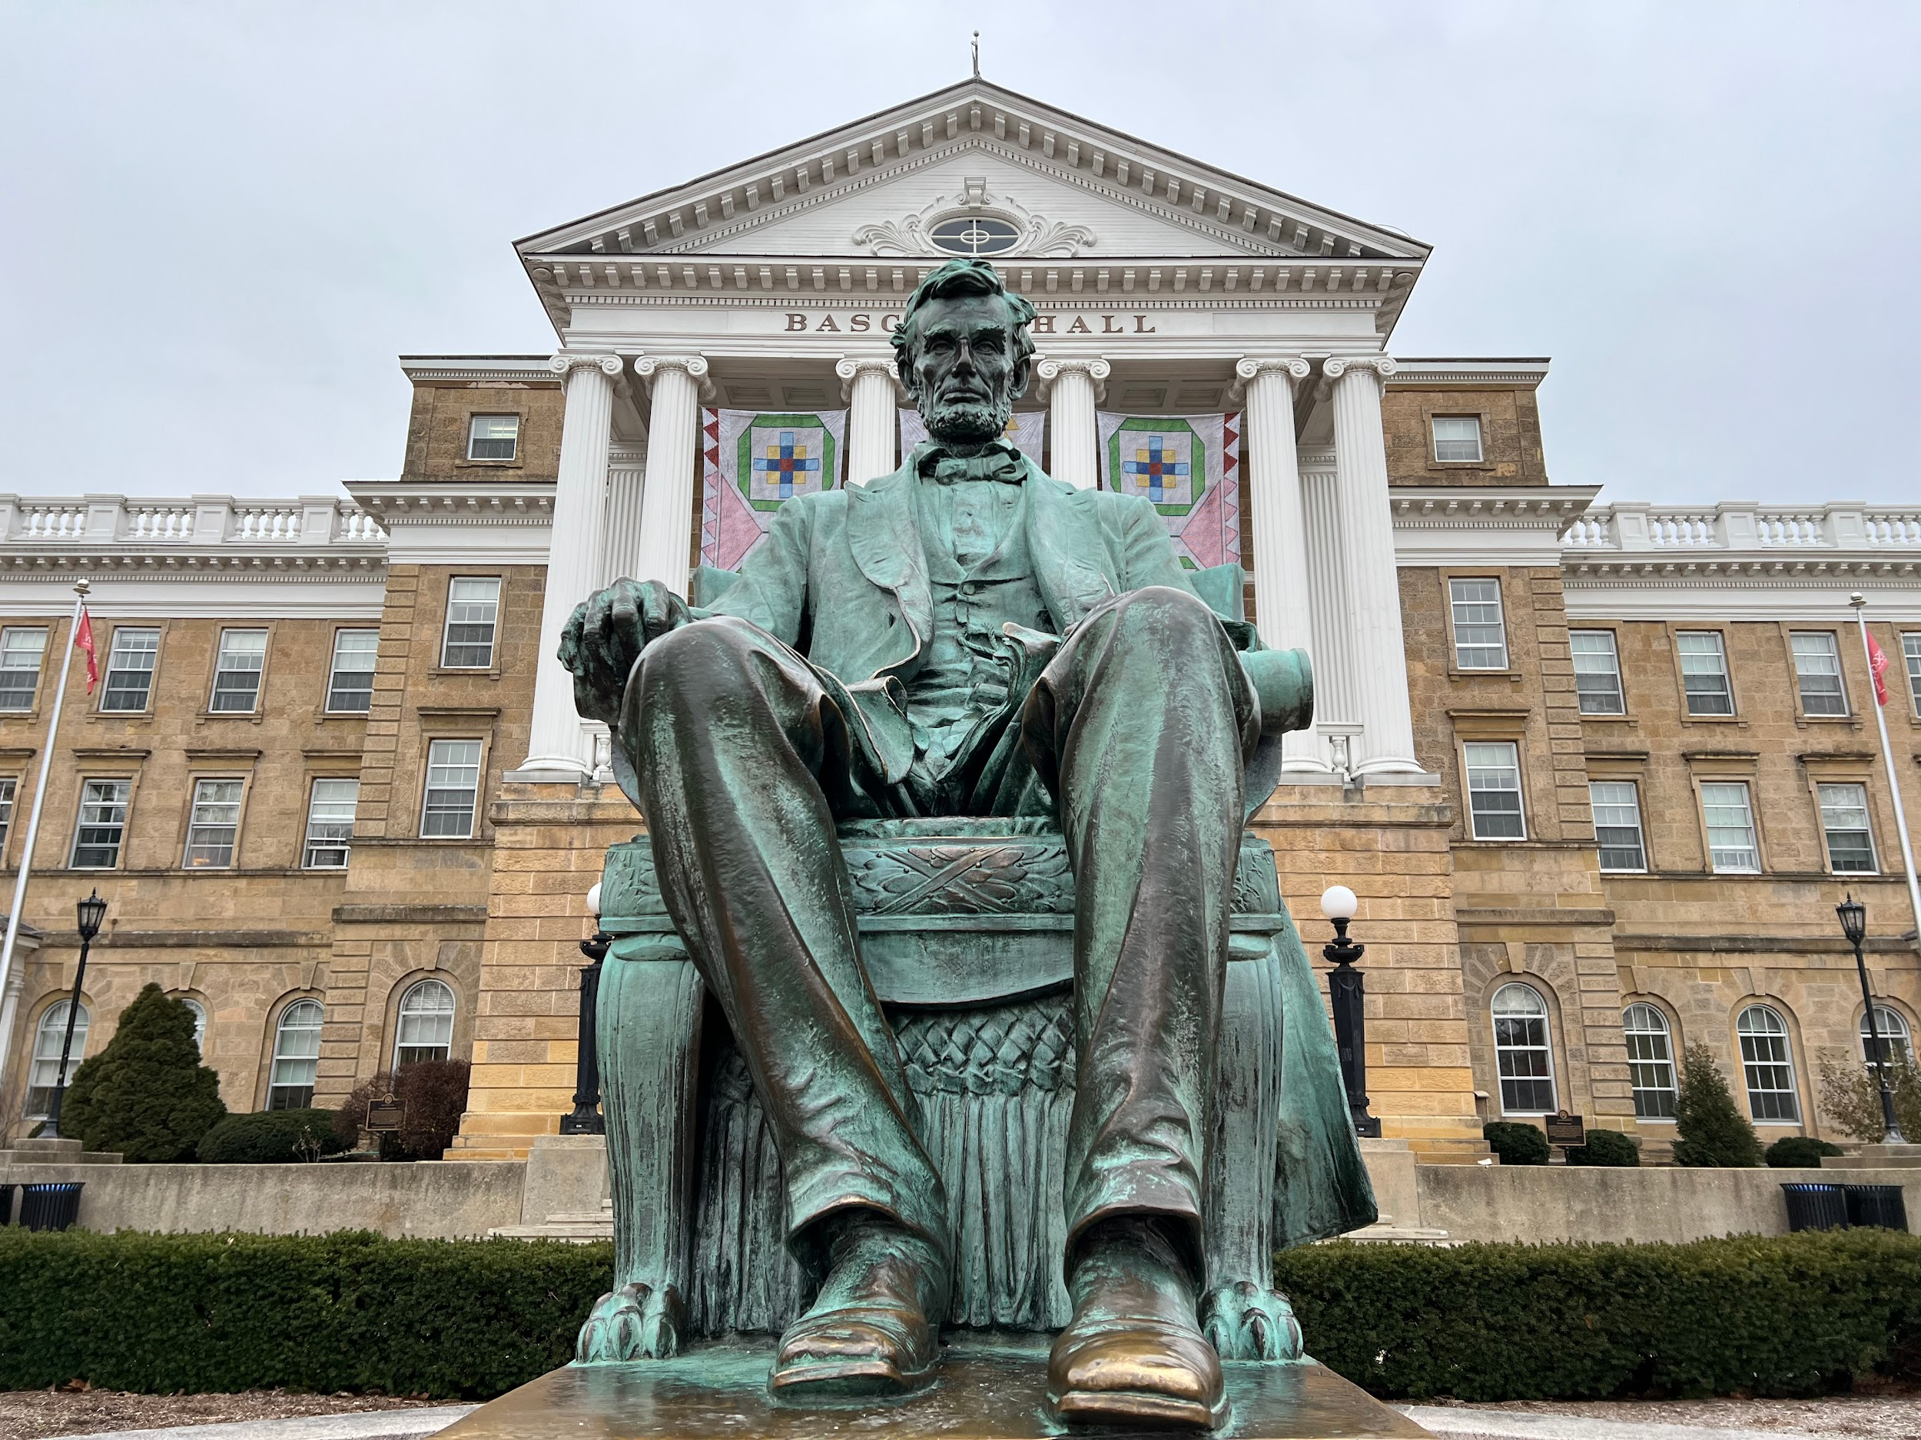

**Bibliography:**

[APLU. “Land-Grant University FAQ.” Accessed December 20, 2023.](https://www.zotero.org/google-docs/?9XHFf9) <https://www.aplu.org/about-us/history-of-aplu/what-is-a-land-grant-university/>[.](https://www.zotero.org/google-docs/?9XHFf9)

[Association, National Education. “Land Grant University Research | NEA,” March 15, 2022.](https://www.zotero.org/google-docs/?9XHFf9) <https://www.nea.org/resource-library/land-grant-university-research>[.](https://www.zotero.org/google-docs/?9XHFf9)

[Department of History. “Timeline – 1848 Founding of the UW.” Accessed December 20, 2023.](https://www.zotero.org/google-docs/?9XHFf9) <https://history.wisc.edu/department-information/the-history-of-the-history-department/timeline-1848-founding-of-the-uw/>[.](https://www.zotero.org/google-docs/?9XHFf9)

[Extension. “Extension’s Impactful History.” Accessed December 20, 2023.](https://www.zotero.org/google-docs/?9XHFf9) <https://extension.wisc.edu/about-us/history/>[.](https://www.zotero.org/google-docs/?9XHFf9)

[Forward? The Wisconsin Idea, Past & Present. “Forward? The Wisconsin Idea, Past & Present.” Accessed October 20, 2023.](https://www.zotero.org/google-docs/?9XHFf9) <https://www.ssc.wisc.edu/soc/wiscidea/>[.](https://www.zotero.org/google-docs/?9XHFf9)

[Henton, Lesley. “Five Questions: The Morrill Act.” Texas A&M Today, July 5, 2021.](https://www.zotero.org/google-docs/?9XHFf9) <https://today.tamu.edu/2021/07/05/five-questions-the-morrill-act/>[.](https://www.zotero.org/google-docs/?9XHFf9)

[“History – Agricultural & Life Sciences.” Accessed October 20, 2023.](https://www.zotero.org/google-docs/?9XHFf9) <https://cals.wisc.edu/about-cals/history/>[.](https://www.zotero.org/google-docs/?9XHFf9)

[*UW Press: John Bascom and the Origins of the Wisconsin Idea*. Accessed October 20, 2023.](https://www.zotero.org/google-docs/?9XHFf9) <https://uwpress.wisc.edu/books/5450.htm>[.](https://www.zotero.org/google-docs/?9XHFf9)

Video Link: [It starts as an idea - UW–Madison celebrates 175 years of service](https://www.youtube.com/watch?v=j1LnAywKYeM&t=6s)

This video, published by UW-Madison in 2023, recalls UW-Madison’s long history of

innovation, stemming from the Wisconsin Idea.

(It starts as an idea - UW–Madison celebrates 175 years of service, 2023)

1. [Association, “Land Grant University Research | NEA.”](https://www.zotero.org/google-docs/?c817sO)
2. [“Land-Grant University FAQ.”](https://www.zotero.org/google-docs/?NcYOB7)
3. [“Land-Grant University FAQ.”](https://www.zotero.org/google-docs/?OhWF3b)
4. [“Timeline – 1848 Founding of the UW.”](https://www.zotero.org/google-docs/?H9afZZ)
5. [“Extension’s Impactful History.”](https://www.zotero.org/google-docs/?KBCyHw)
6. [Henton, “Five Questions.”](https://www.zotero.org/google-docs/?cg64XS)
7. [*UW Press*, 101.](https://www.zotero.org/google-docs/?9kpEYz)
8. [“Extension’s Impactful History.”](https://www.zotero.org/google-docs/?L1B45q)
9. [*UW Press*.](https://www.zotero.org/google-docs/?vCw1Fk)